# Hale Construction

## Website Content

### Home

**J G HALE GROUP**

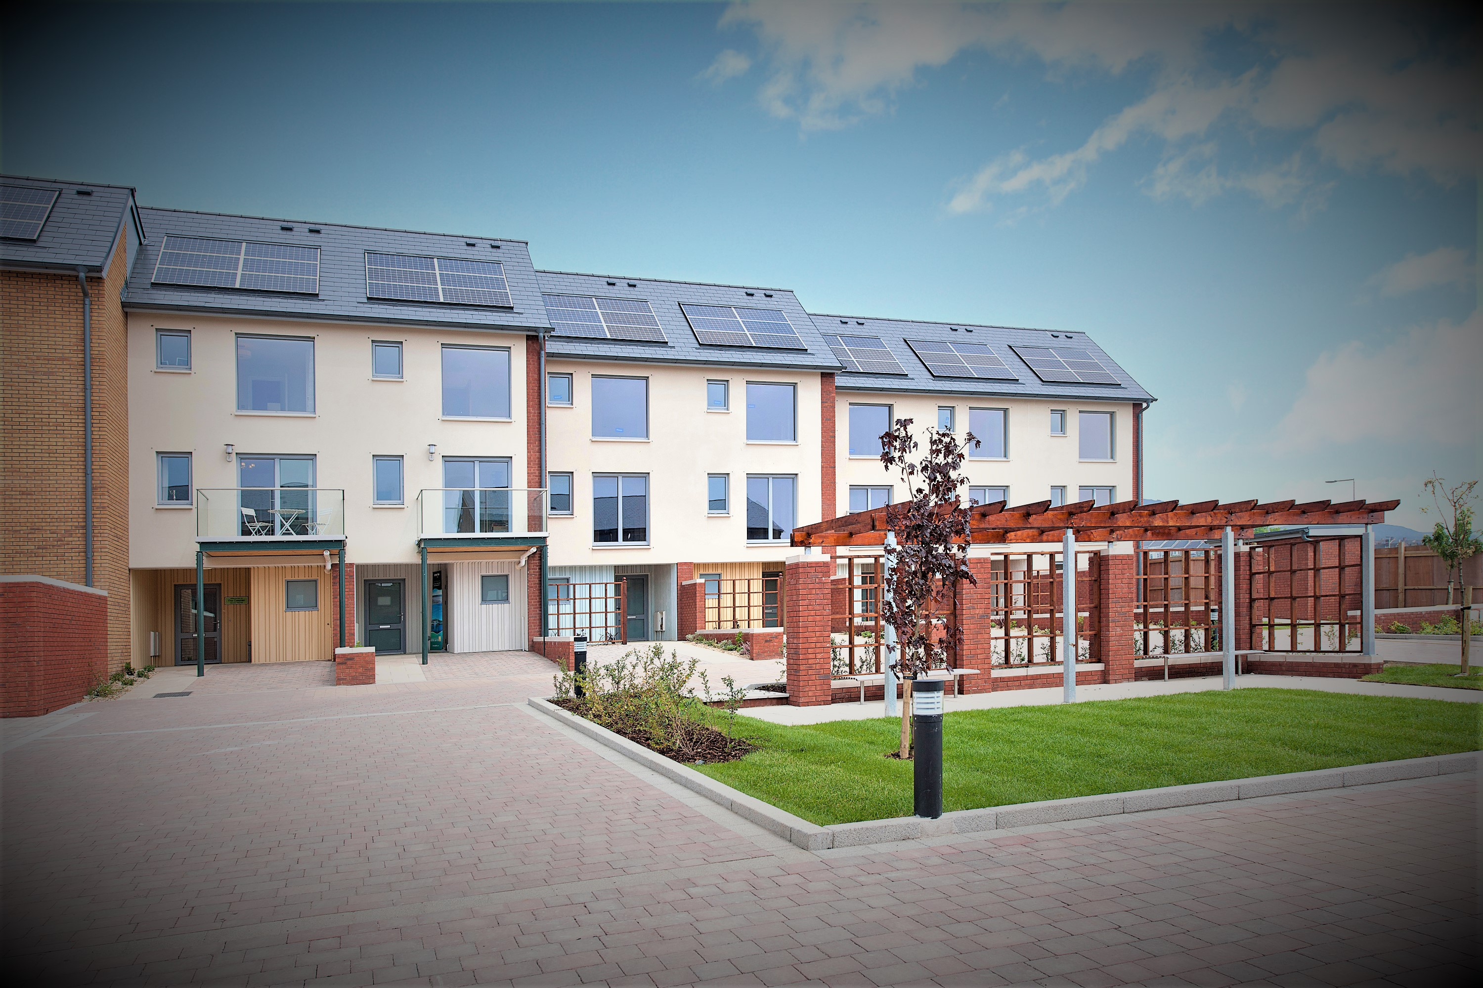

#### Section 1

Three key captivating headers and images that can link to other sections. Images can match header images of other pages:

1. **Eco friendly Construction**

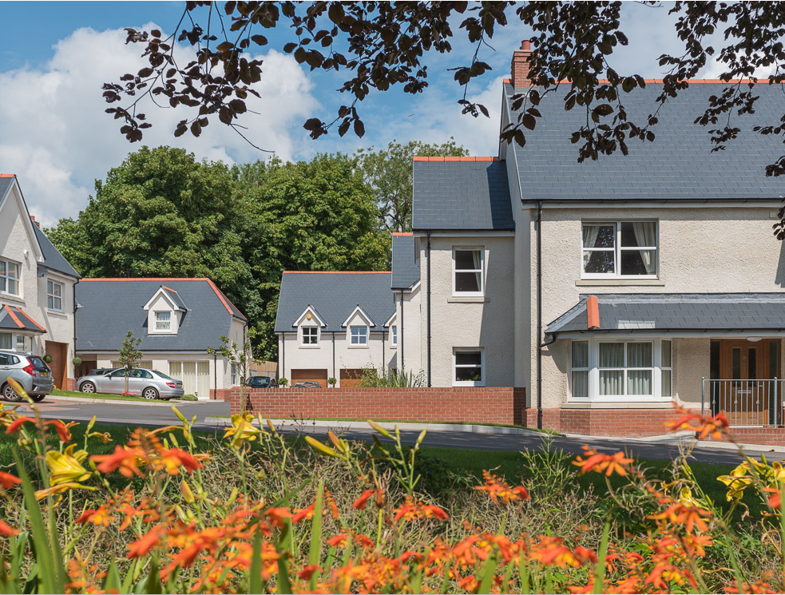

1. **Construction**

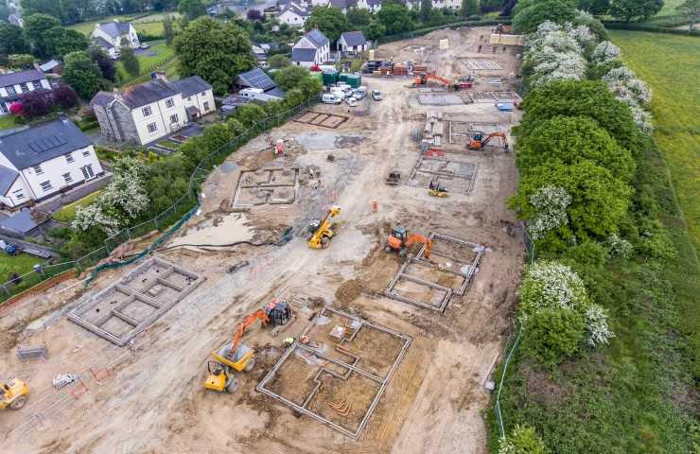

1. **Leadership**

**C:\Users\amy.richards\AppData\Local\Microsoft\Windows\INetCache\Content.Word\030609_004.tif**

#### Section 2

A link to the history of the company:

1. 20 years of history
   1. Image to reflect title ( photo of Jon around 1996)

#### Section 3

A link to 3 random featured projects. This will be auto generated based upon the case studies provided.

### History

An introduction and quotation from J.H. Followed by a history of the company. Can have multiple images per year if needed.

1. 20 years of Experience
   1. Title
2. Introduction & Quote

**J G Hale Construction was established in 1999 and since then the company has continued to grow substantially, delivering a number of high- quality developments for their private sector, Hale Homes and for numerous Housing Associations and Local Authorities across Wales.**

**Base in Neath, South Wales, this family run business has grown rapidly due to their commitment to making the client their number one priority. Hale conscientiously take the time to listen to their clients to create a bespoke design package to ensure the end result is tailor made to a high standard and cost effective.**

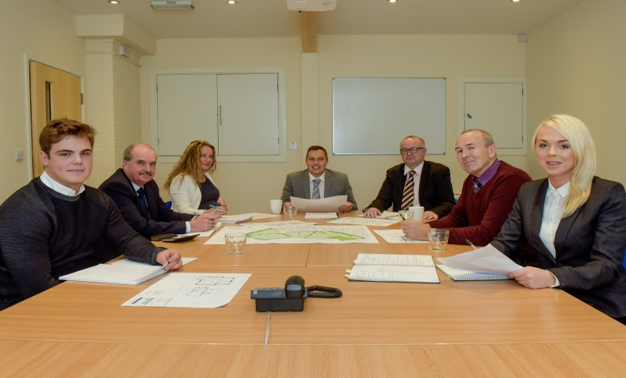

* 1. Quote

1. In The beginning

**The Hale name has a long standing history within the construction industry of South Wales. Both Jonathan’s father and uncle had a construction company and received many awards for their developments through the years.**

**Jonathan started out as a trainee carpenter as a teenager, and sees this trade as a key to what he does today.**

**In 1996, with the guidance of his father, he established Seven Oaks Joinery. At the time, the company consisted of just Jonathan and one other member of staff. Over time the company grew and Jonathan decided to expand into the construction industry and founded J G Hale Construction in 1999.**

**Hale Homes was launched in 2008, producing quality private homes, the first development being ??????**

**In recent years Jonathan’s son, Graham and daughter, Charlotte have joined the family business as Site Managers. In 2018 Charlotte took on the role as head of Sevenoaks Modular, Hale’s sister timber frame company.**

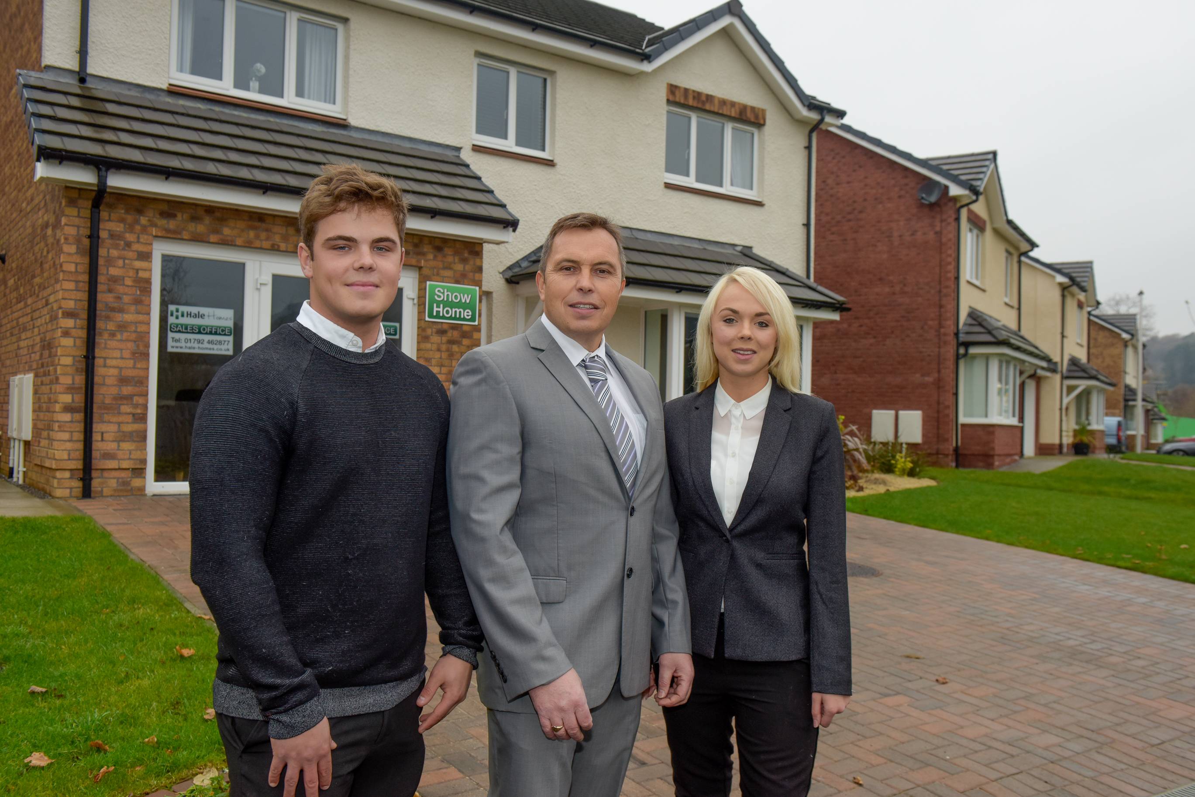

**Both Hale Construction and Hale Homes have received numerous awards for their developments and have grown from strength to strength.**

**This next year could stand to be the biggest in J G Hale’s history. January currently has 16 developments underway and a further 10 in the pipe line, the company shows no signs of slowing down. With this growth, the company are due to move to larger premises along with Sevenoaks Modular to further expand the businesses.**

### Green and Eco friendly Construction

What Hale does to protect the environment. Introduction followed by how ever many sections required.

1. Eco friendly Construction

Sustainably is a core value which is reflected in how Hale design their energy efficient homes and how the business is run. All houses are designed to be energy efficiency and use sustainable materials wherever possible. The timber frame houses are produced using timber which is responsible forest and managed. Cutting edge insulation techniques, using a foam insulation product which can cuts energy bills by up to 90%.

Biomass boilers have been installed at the Neath head office and are fuelled by offcuts from its sister company Sevenoaks Modular. Not only does this ensure that resources are not wasted, it also saves on the company’s energy consumption.

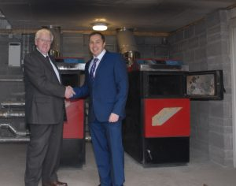

Green Living

Hale have a passion for nature and the environment which is stemmed from Jonathan and his family. With every development, the environmental impact is considered and all aspects are taken to reduce these effects. Many of their developments encourage wild life by planting trees, hedgerows and bee –friendly plants and erecting bird and bat boxes. Sites will often include open spaces and green areas because of the positive impact on both nature and the community.

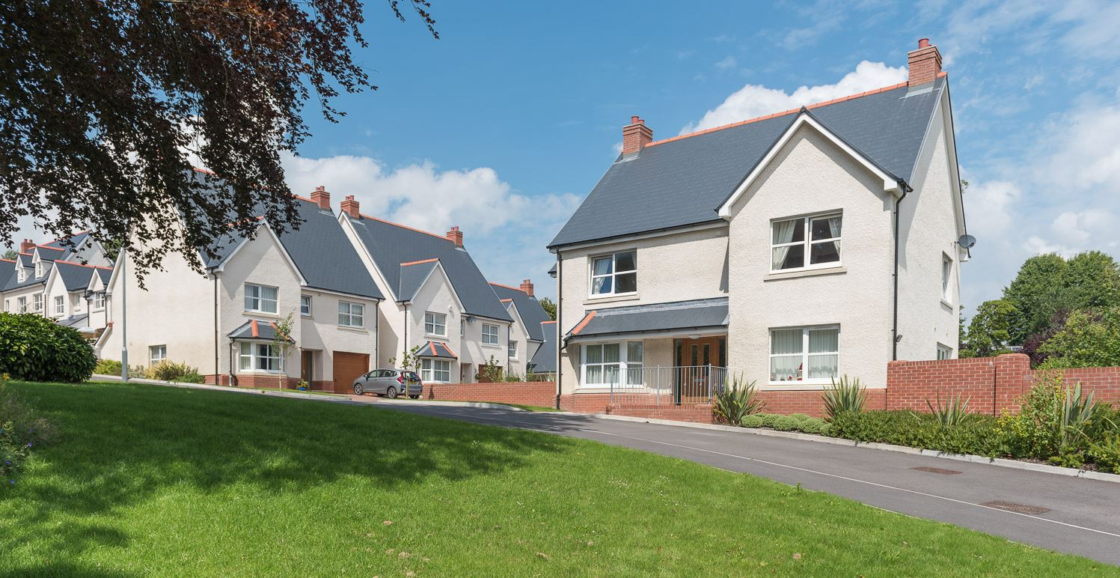

### Leadership

About the Hale construction leadership.

1. Leading from the Front
   1. Title



Jonathan Hale – Chairman

Jonathan set up Hale Construction in 1996, following years of experience in the construction industry in South Wales.

Jonathan believes the company’s success is in part due to a hands-on approach from management.

Under Jonathan’s Chairmanship, Hale has grown and now includes sister companies, Hale Homes and Sevenoaks Modular.

His best moment so far has been seeing his son and daughter run construction sites for Hale.



David Harrhy – Managing Director

As Managing Director, David is responsible for Hale Construction’s overall performance, overseeing company policy and implementing change.

He also uses his thirty years of experience in the construction sector to lead on coaching and mentoring staff.

David first realised he wanted to work in the construction industry when he started out as a trainee engineer. Before joining Hale, he spent twenty-five years at Gee Construction, working as Director for the South West.



Ceri Brown – Financial Director

Alongside coordinating all accounting and payroll functions, Ceri is always looking for ways to offer the most cost effective solution to the customers. She has developed a cost management system to track expenses throughout each project.

After graduating with a MEng Honours Degree in Engineering from Oxford University, Ceri’s first job was at an accountancy firm where she learnt the crucial skills of attention to detail and being able to prioritise workloads.

Ceri enjoys sailing, knitting and spending time with her family.

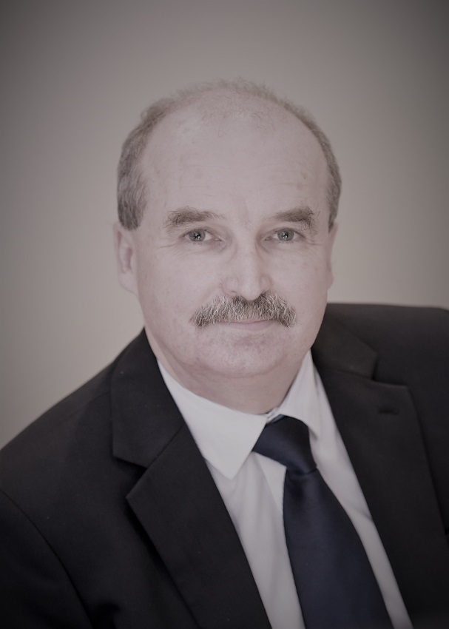

David Llewelyn - Commercial Director

David manages the quantity surveying scheme and is responsible for ensuring that builds are delivered on budget and on time.

David is an expert at delivering complex projects and maintains responsibility for budget preparation, subcontract procurement, expenditure control and financial reporting at Hale.

With over 30 years’ experience in construction, David has worked on a variety of projects from multi million pound developments to Welsh Assembly schemes and heritage sites.

David enjoys gardening, walking and keeping fit.

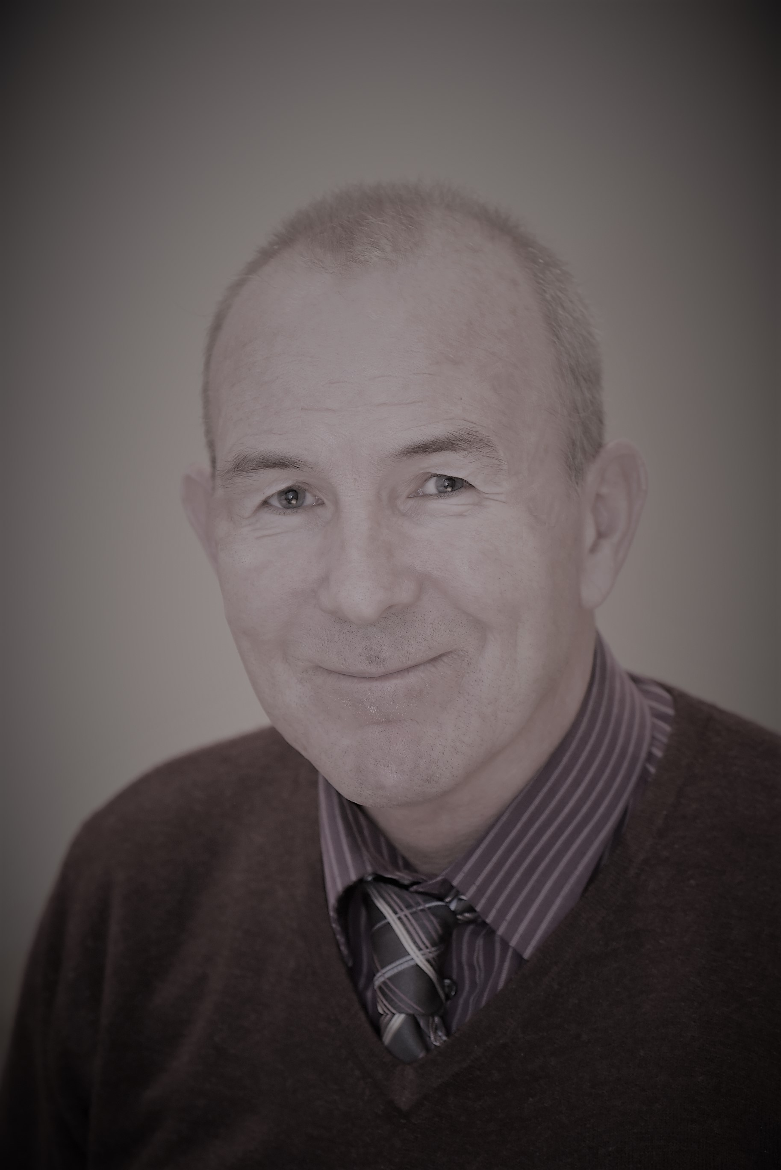

Kevin O’Mahony – Contracts Director

Kevin is a Contracts Directors and Co Director of Hale. As winner of an NHBC award, he brings invaluable expertise to the company.

When Kevin joined Hale in 2000, he arrived with a wealth of contract management experience as well as strong technical and organisational skills. He has worked on the most high profile housing contracts, helping Hale to build its reputation.

Kevin originally started in the industry as a carpentry apprentice some 30 years ago. Now when not helping to build homes, he likes to put his mark on his own home.

Mal Thomas - Contracts Director

Malcolm is a Contracts Director at Hale. With exceptional knowledge of building regulations and planning, he helps the team focus on projects.

Malcolm is known for taking a considered approach to collaborating with clients, supply chain members and trade, ensuring that value for money is pursued and potential IR pitfalls avoided.

Malcolm developed his way of working when starting out as a carpenter where he learnt the benefits of taking the time to do things right the first time.

Since working at Hale his highlight has been completing a big project of 112 units at Cwmfelin.

### Health and Safety

Hale believe health and safety is the most important consideration before any construction project is initiated. The construction industry is prone to hazardous situations and can be dangerous a lot of the time. Hale are very proactive in accident prevention and provide personnel, weekly training updates on site and relevant training throughout the year to ensure they are fully aware of all health and safety aspects and promotes a positive attitude to H & S. As well as offering employees suitable training and information, Hale regular complete risk assessments and take any necessary steps to reduce the dangers identified in these analyses.

Key Facts

* Health and safety failures cost Great Britain up to £18 billion each year.
* 400 people every year are still killed in accidents caused by work activities.
* Around 25 million working days are lost every year as a result of work-related accidents and ill-health.
* Over 25,000 people are forced to give up work every year as a result of work-related accidents and ill-health.
* Around 2 million people - 5 per cent of the population - suffer from ill-health caused by work.

Michael Whelan

Group Health and Safety Manager

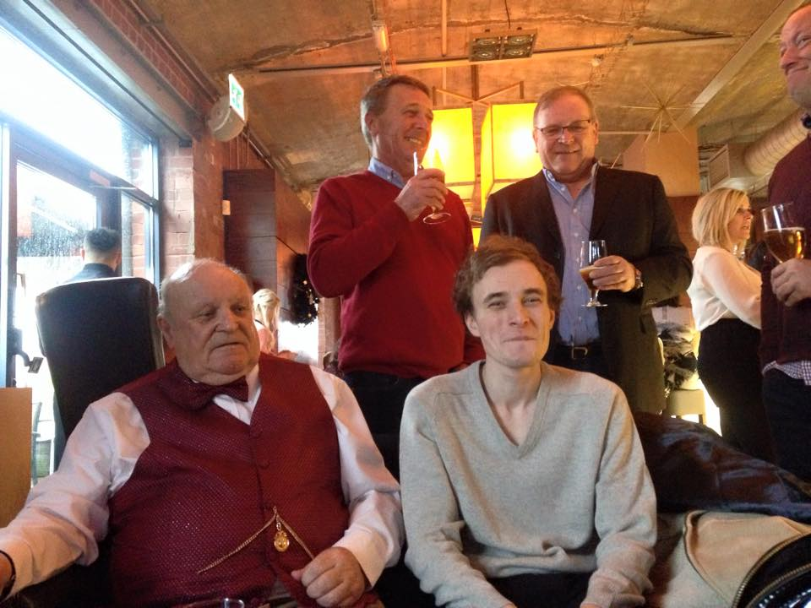

Michael has worked in Construction for over 43 years, starting as a Bricklayer, Bricklaying Foreman, City and Guilds Construction Assessor, Site Manager and then on to Health and Safety. He is currently a continuous member of IOSH, CEIH, Institute of Fire Engineers and the Institute of Fire Safety Managers. Michael joined the company in August 2015 and has watched Hale expand and deliver projects over a wide area around South Wales. His commitment to excellent health and safety awareness is obvious in the standard on sites and the numerous accreditations that Hale has won. He is committed to working well with Contracts Managers and Site Managers to ensure everyone is working towards the same goal with health and safety being a major priority.

(Quote)

“A health and safety problem can be described by statistics but cannot be understood by statistics. It can only be understood by knowing and feeling the pain, anguish and depression and shattered hopes of the victim and of the wives, husbands, parents, children, grandparents and friends”

### Accreditations

[](https://www.bing.com/images/search?q=iosh+logo&id=33D5F100EEBEFF91A622B0B1CFAE7AD753D92667&FORM=IQFRBA)

Health and Safety

1. Health and Safety
   1. Title
   2. Image
2. Introduction
3. Accreditations:
   1. Header
   2. Stamp (image)
   3. Small Description
   4. Link to website
   5. Document

### News

Just move current news and update with recent marketing

### Policies

Please list policies you’d wish to display on the website:

1. Privacy
2. Anti-Slavery
3. Cookies
4. Terms & Conditions (for website)
5. Health and Safety

### Construction

A page related to purely Hale. How you work, how you achieve. A page to sell hale and its services.

**J G Hale Construction have worked in various sectors including, healthcare, residential, commercial and public services. Hale Construction are currently collaborating with a number of Housing Associations and undertake new build projects around Wales.**



**From the start Hale, with their wealth of knowledge and experience will plan with their clients to produce a development to be proud of. They will discuss at length to ensure the clients requirements are met and create cost effective solutions. Their team of Quantity Surveyors, Contracts Managers and Site Managers will work with you to ensure your development is completed efficiently but to the highest standard in regards to quality and Health and Safety.**

### Hale Homes

A page related to Hale homes and a link to hale homes website

Hale Homes, a luxury house-builder based in Neath, South Wales, providing contemporary homes with spectacular design and high standard specification. Hale homes are designed for both families and individuals in mind and maximises on the useable space.

The focus is on building high quality homes with the most sustainable sources available - it's an approach which has seen us win awards for sustainable design.

### SO Modular

Sevenoaks Modular Ltd are a rapidly expanding timber frame manufacture with our headquarters based in South West Wales. Our highly experienced, growing workforce can ‘Design, Supply and Erect’ your timber frame – home, apartment block, retail outlet or education establishment, on time, on budget and of the highest quality standard.

### Projects

Must discuss. How you want to display and what style of key information you want for a project covering COMPLETED and CURRENT.

### Contact

01639 622189

[info@haleconstruction.co.uk](mailto:info@haleconstruction.co.uk)

Address and map

Just let me know what primary method of contact you’d prefer. If you want a map, address, email, phone etc.